Day 12 (27 June 2025)
112552596 - vsisukhw - Sukhwinder Singh

For tasks questions , refer
https://docs.google.com/document/d/156Oa4jimJc23DTTtE173kOkFclQMC8Aya_UN_0sYj5s/edit?tab=t.0

Task 1
What do you understand about data structures?

Data structures are ways to organize and store data so that we can use it efficiently.
Imagine a toolbox:
- A list or array is like a row of drawers where each one holds something.
- A stack is like a stack of plates — you can only take the top one (Last In, First Out).
- A queue is like a line at a ticket counter — first come, first served (First In, First Out).
- A linked list is like a chain where each piece points to the next.
- A tree is like a family tree, with a top parent (root) and many branches.
- A graph is like a map, showing how places (nodes) are connected by roads (edges).
- A hash table is like an index in a book — you look up a key (like a word) to quickly find the page (value).

Task 2
What are the types of data structures. List them out.

Types of data structures:

1. Linear Data Structures
- Array
- Linked List
  - Singly Linked List
  - Doubly Linked List
  - Circular Linked List
- Stack
- Queue
  - Simple Queue
  - Circular Queue
  - Priority Queue
  - Deque (Double Ended Queue)

2. Non-Linear Data Structures
- Tree
  - Binary Tree
  - Binary Search Tree (BST)
  - AVL Tree (Self-balancing BST)
  - B-Tree, B+ Tree
  - Heap (Min-Heap, Max-Heap)
  - Trie (Prefix Tree)
- Graph
  - Directed Graph
  - Undirected Graph
  - Weighted Graph
  - Unweighted Graph
  - Cyclic / Acyclic Graph

3. Hash-Based Structures
- Hash Table
- Hash Map
- Hash Set

4. Special/Advanced Data Structures
- Matrix
- Disjoint Set (Union-Find)
- Segment Tree
- Fenwick Tree (Binary Indexed Tree)
- Skip List
- Bloom Filter
Task 3
What all operations can we do in Data structures?

In Data Structures, we can perform various basic and advanced operations to manage and process data. Here are the most common ones:

Basic Operations
- Insertion
  - Add a new element to the data structure.
- Deletion
  - Remove an element.
- Traversal
  - Visit each element (one by one), e.g., print all values.
- Searching
  - Find the location of an element.
- Updating
  - Change the value of an existing element.

Other Common Operations
- Sorting
  - Arrange elements in a specific order (ascending or descending).
- Merging
  - Combine two data structures.
- Accessing
  - Directly reach an element (e.g., using an index in an array).
Task 4
What are static and dynamic arrays? Explain or summarize key points in a table like Size, performance, memory, flexibility, limitations.

Static vs Dynamic Arrays :

Aspect | Static Array | Dynamic Array
Size | Fixed size (set at creation) | Can grow or shrink at runtime
Performance | Fast for access (no resizing) | Slightly slower during resizing
Memory | Allocated at compile-time (usually on stack) | Allocated at runtime (usually on heap)
Flexibility | Less flexible — cannot change size | More flexible — can resize as needed
Limitations | Wastes memory if size too big; cannot expand | May need more memory and resizing takes time

Task 5
What is Binary value of ‘a’ ? (ASCII Value = 97)

Division Step | Quotient | Remainder
97 ÷ 2 | 48 | 1
48 ÷ 2 | 24 | 0
24 ÷ 2 | 12 | 0
12 ÷ 2 | 6 | 0
6 ÷ 2 | 3 | 0
3 ÷ 2 | 1 | 1
1 ÷ 2 | 0 | 1
Remainders from bottom to top:
1 1 0 0 0 0 1 → Add a leading 0 to make it 8 bits:
01100001
So, the binary of 'a' is : 01100001

Task 6
Types of Computer memory with Examples. Explain .

1. Primary Memory (Main Memory)

This is the memory your computer uses while it’s working. It is fast but temporary.
- RAM (Random Access Memory) stores the programs and data you're using right now. Once the computer is turned off, it gets cleared.
- ROM (Read-Only Memory) contains permanent instructions like how to start the computer (called BIOS).
- Cache is a small, very fast memory inside the CPU that stores frequently used data.
- Registers are even smaller and faster, used inside the CPU to do quick tasks like calculations.

2. Secondary Memory (Storage)
This memory is permanent and stores your files, apps, and data even after shutting down.
- Hard Disk (HDD) is a traditional storage device. Slower but cheaper and offers more space.
- SSD (Solid State Drive) is much faster and found in modern laptops and PCs.
- Pen Drives and SD Cards are small and portable – used to transfer data.
- CDs and DVDs are older types used to store media and software.

3. Tertiary Memory (Backup/Archive)
This type of memory is used for backups or storing data that you don’t use often.
- Magnetic Tapes are used in big companies for backup.
- Cloud Storage stores your files online (like Google Drive or Dropbox), and you can access them from anywhere with internet.

4. Virtual Memory
When your RAM is full, the computer uses a part of your hard disk as extra memory.
It’s slower than real RAM but helps to keep your computer running instead of crashing.

Task 7
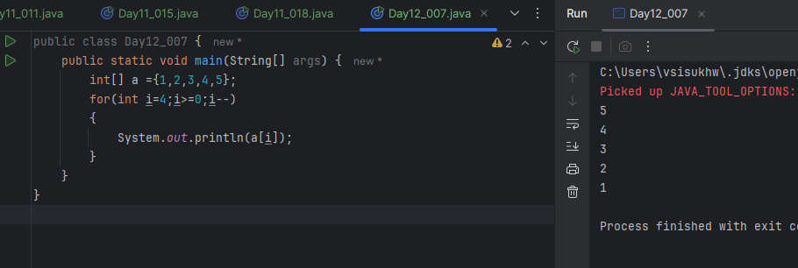
Task 8
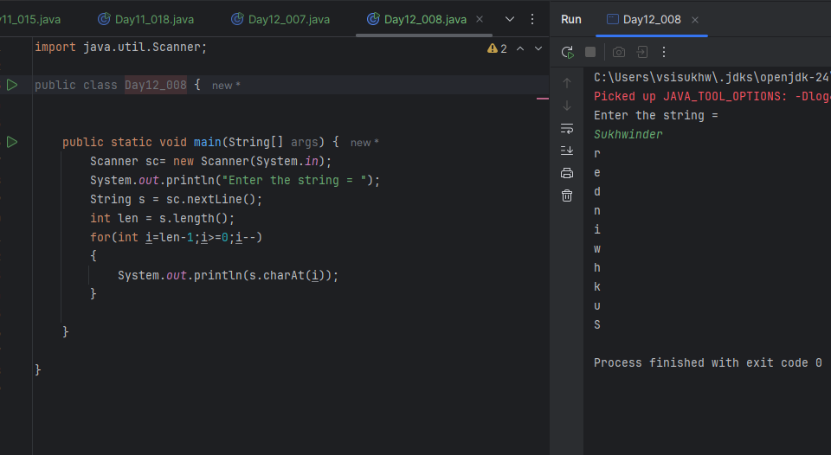
Task 9
Created Leetcode
Login id - vsisukhw

Task 10
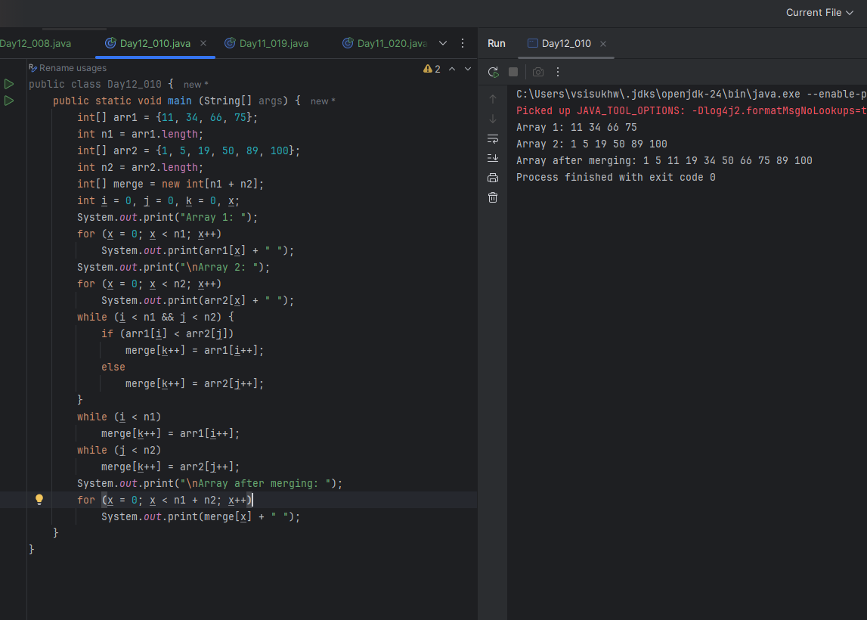
This Java program is designed to merge two already sorted arrays into a single sorted array. It begins by initializing two arrays: arr1 containing {11, 34, 66, 75} and arr2 containing {1, 5, 19, 50, 89, 100}. These arrays are printed first to show the original data. Then, the program creates a third array called merge, large enough to hold all the elements from both arrays.
Using a two-pointer technique, the program compares elements from arr1 and arr2 one by one. The smaller element is placed into the merge array, and the corresponding pointer is moved forward. This process continues until one of the arrays is completely traversed. After that, any remaining elements from the other array are copied directly into the merge array.
Finally, the program prints the contents of the merged array, which results in a fully sorted combination of the two input arrays. The output shows the merged array as: 1 5 11 19 34 50 66 75 89 100. Overall, the program efficiently merges two sorted arrays into one sorted array using a simple and effective approach.

Task 11
What do you understand by Hash table?

A hash table is a data structure that stores data in key–value pairs and allows fast access to values based on a key.
Think of a school locker system:
- The student name is the key.
- The locker is the memory location.
- The books inside are the value.

Task 12
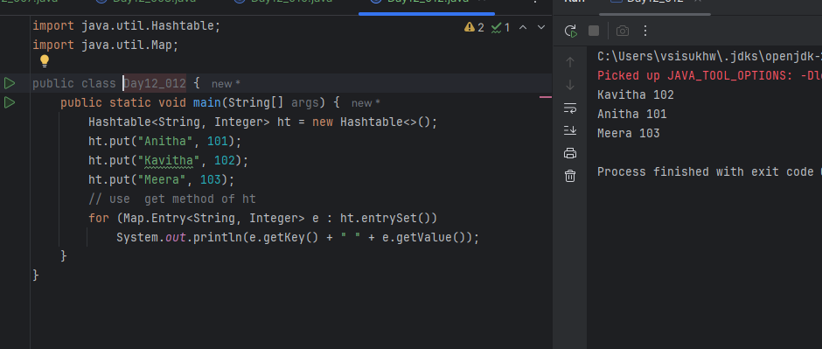

Task 13
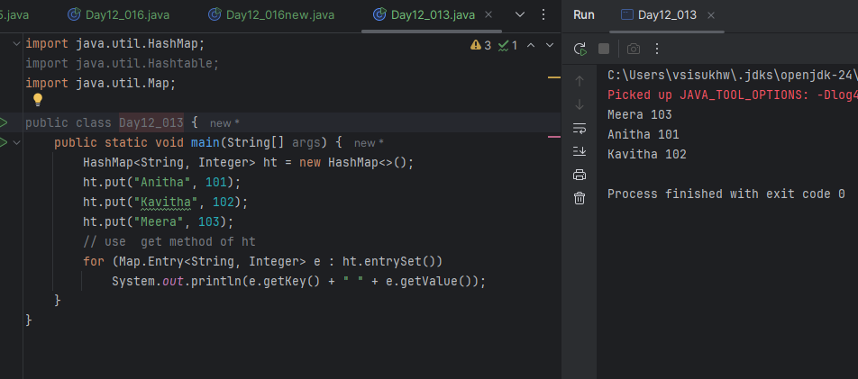
Task 14

Difference between Hash Table and Hash Map

Feature | HashTable | HashMap
Thread-safe | Yes (synchronized) | No (not synchronized)
Performance | Slower (because of synchronization) | Faster (better for single-thread use)
Null keys/values | Does not allow null keys or values | Allows one null key and multiple null values
Usage in multi-threading | Safe for multi-threaded use | Needs manual synchronization (e.g., Collections.synchronizedMap())
HashMap
- Null key – Allowed. You may store exactly one entry whose key is null; any later put with a null key simply replaces the earlier value.
- Duplicate values – Allowed freely. A value can repeat in any number of entries.
(Keys must still be unique; inserting the same key again just overwrites its previous value.)

Hashtable
- Null key – Not allowed. Calling put(null, value) (or get(null)) throws a NullPointerException.
- Duplicate values – Also allowed; only keys must be unique. Like HashMap, inserting the same key again overwrites the old value, but you can store the same value under many different keys.

Similarity between Hash Table and Hash Map

Hash table and Hash Map have linked list internally.
Collisions occur in Hash Table and Hash Maps.

Task 15
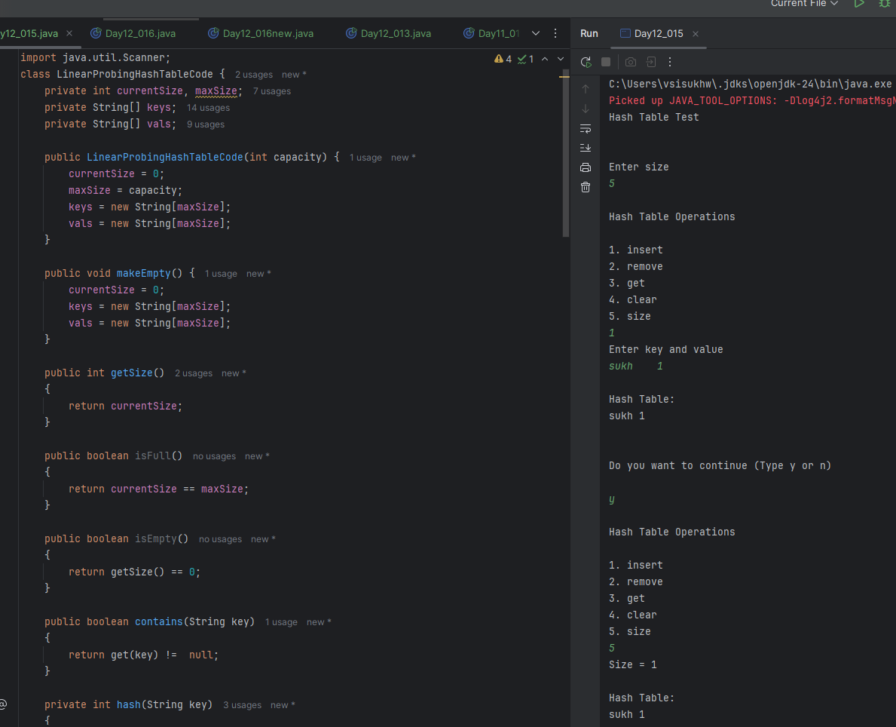
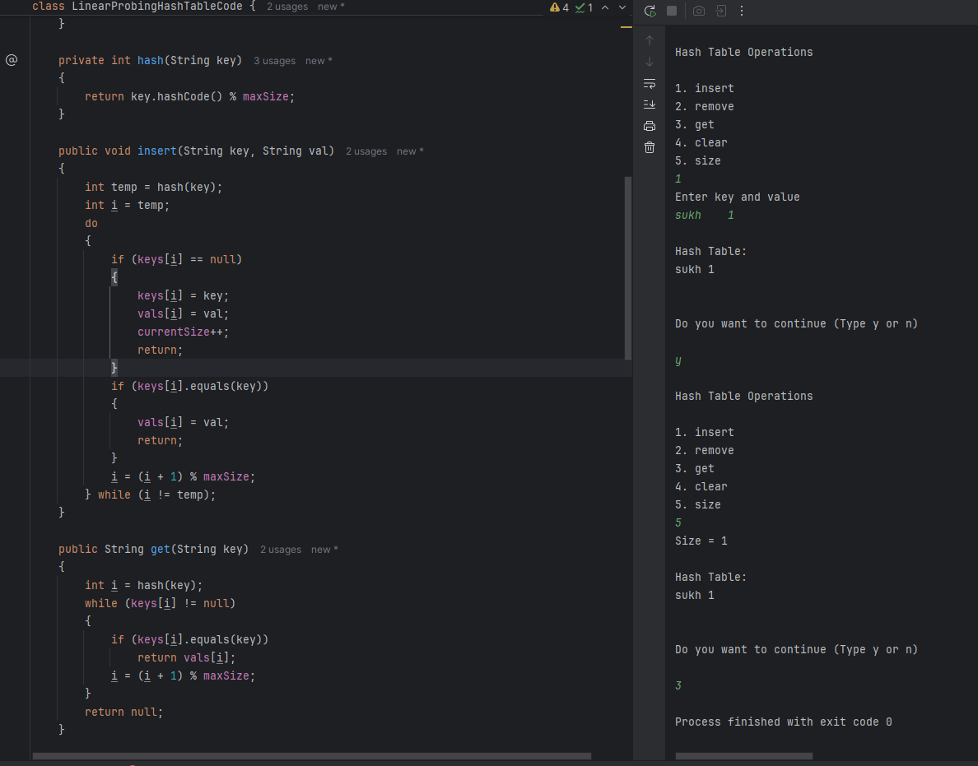
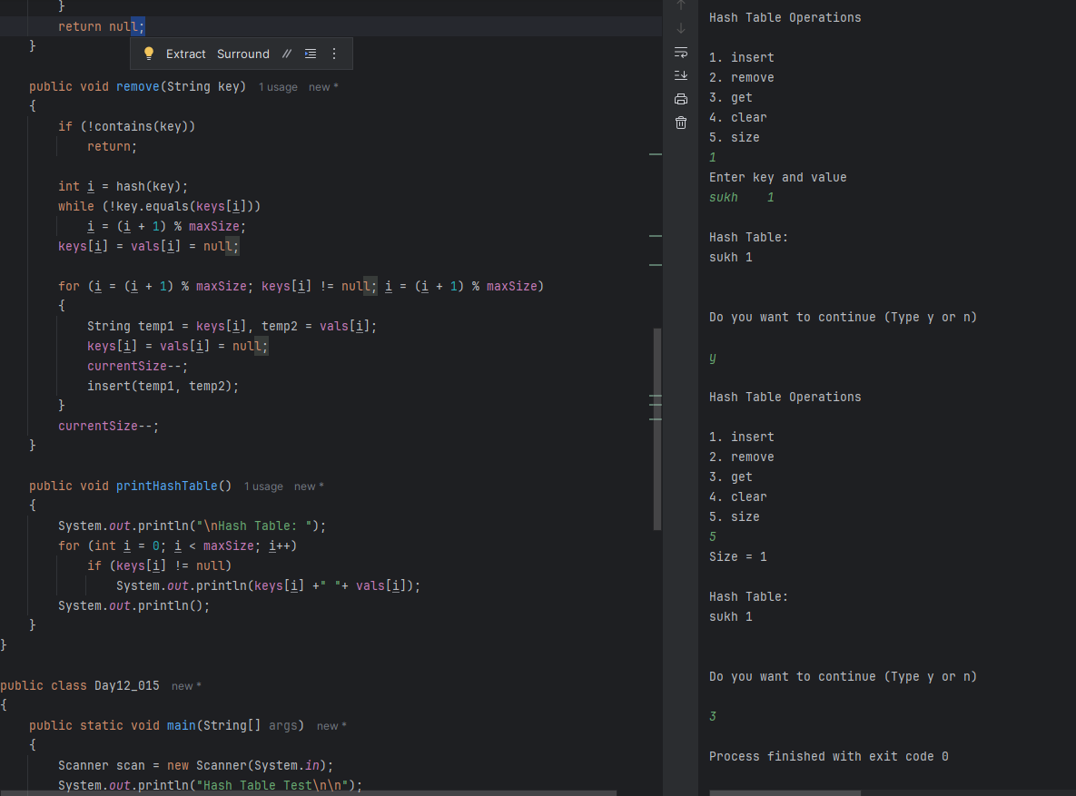
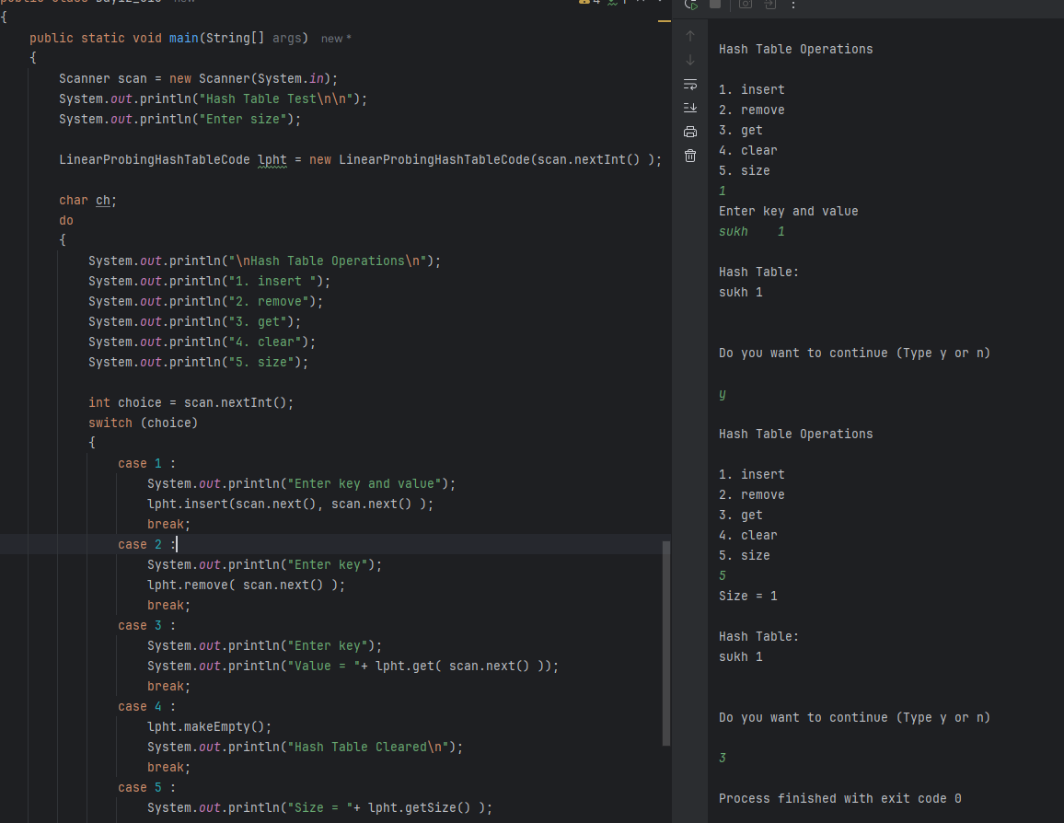
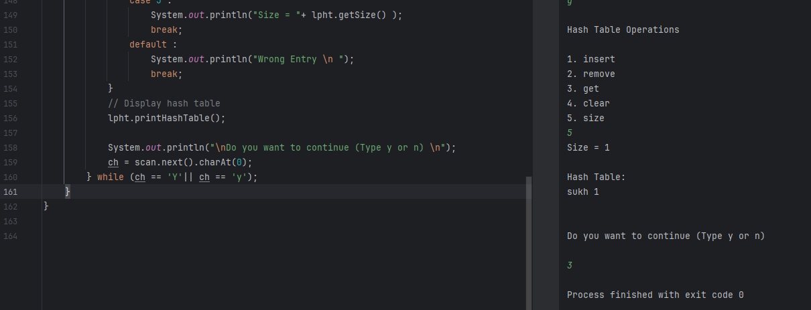

Task 16
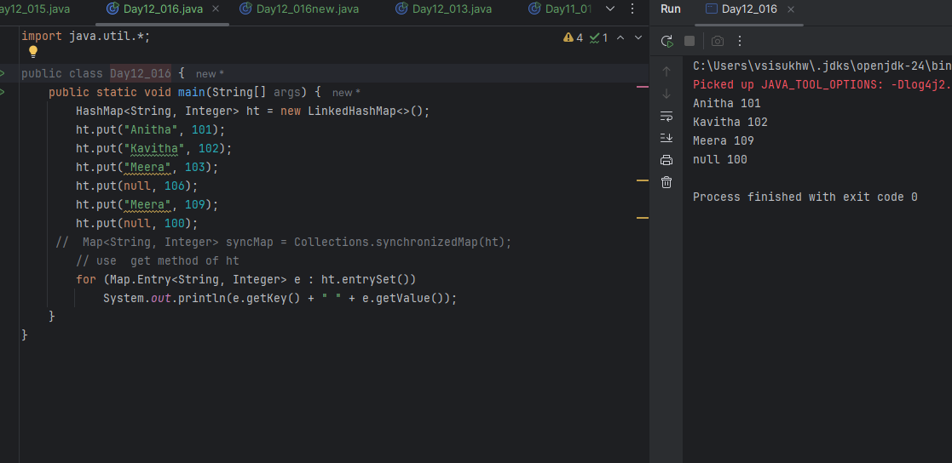

Task 16(01)
